Name : BHOOMIKA.N.N

E-Mail : [bhoomikavviet12@gmail.com](mailto:bhoomikavviet12@gmail.com)

1. Write a C++ program to find area of a circle, triangle and rectangle. Keep the following things in mind:

a. User will first choose shape.

b. User will enter required inputs, such as radius if opted for circle and similarly for rectangle and triangle.

c. Name of functions must be "area"

d. Example output: Area of triangle is 144 sq. units.

Program:

#include<iostream>

#include<math.h>

using namespace std;

int main()

{

float a,b,c,s,r,area;

int ch;

cout<<"1.Area Of Circle";

cout<<"\n2.Area Of Rectangle";

cout<<"\n3.Area Of Triangle \n";

cout<<"\nEnter Your Choice :";

cin>>ch;

switch(ch)

{

case 1:

{

cout<<"\nEnter Radius Of The Circle: ";

cin>>r;

area=3.14\*r\*r;

break;

}

case 2:

{

cout<<"\nEnter Length And Breadth Of Rectangle:";

cin>>a>>b;

area=a\*b;

break;

}

case 3:

{

cout<<"\nEnter Three Sides Of The Triangle:";

cin>>a>>b>>c;

s=(a+b+c)/2;

area=sqrt(s\*(s-a)\*(s-b)\*(s-c));

break;

}

default: cout<<"\n Invalid Choice Try Again...!!!";

break;

}

cout<<"Area = "<<area<<endl;

return 0;

}

OUTPUT:

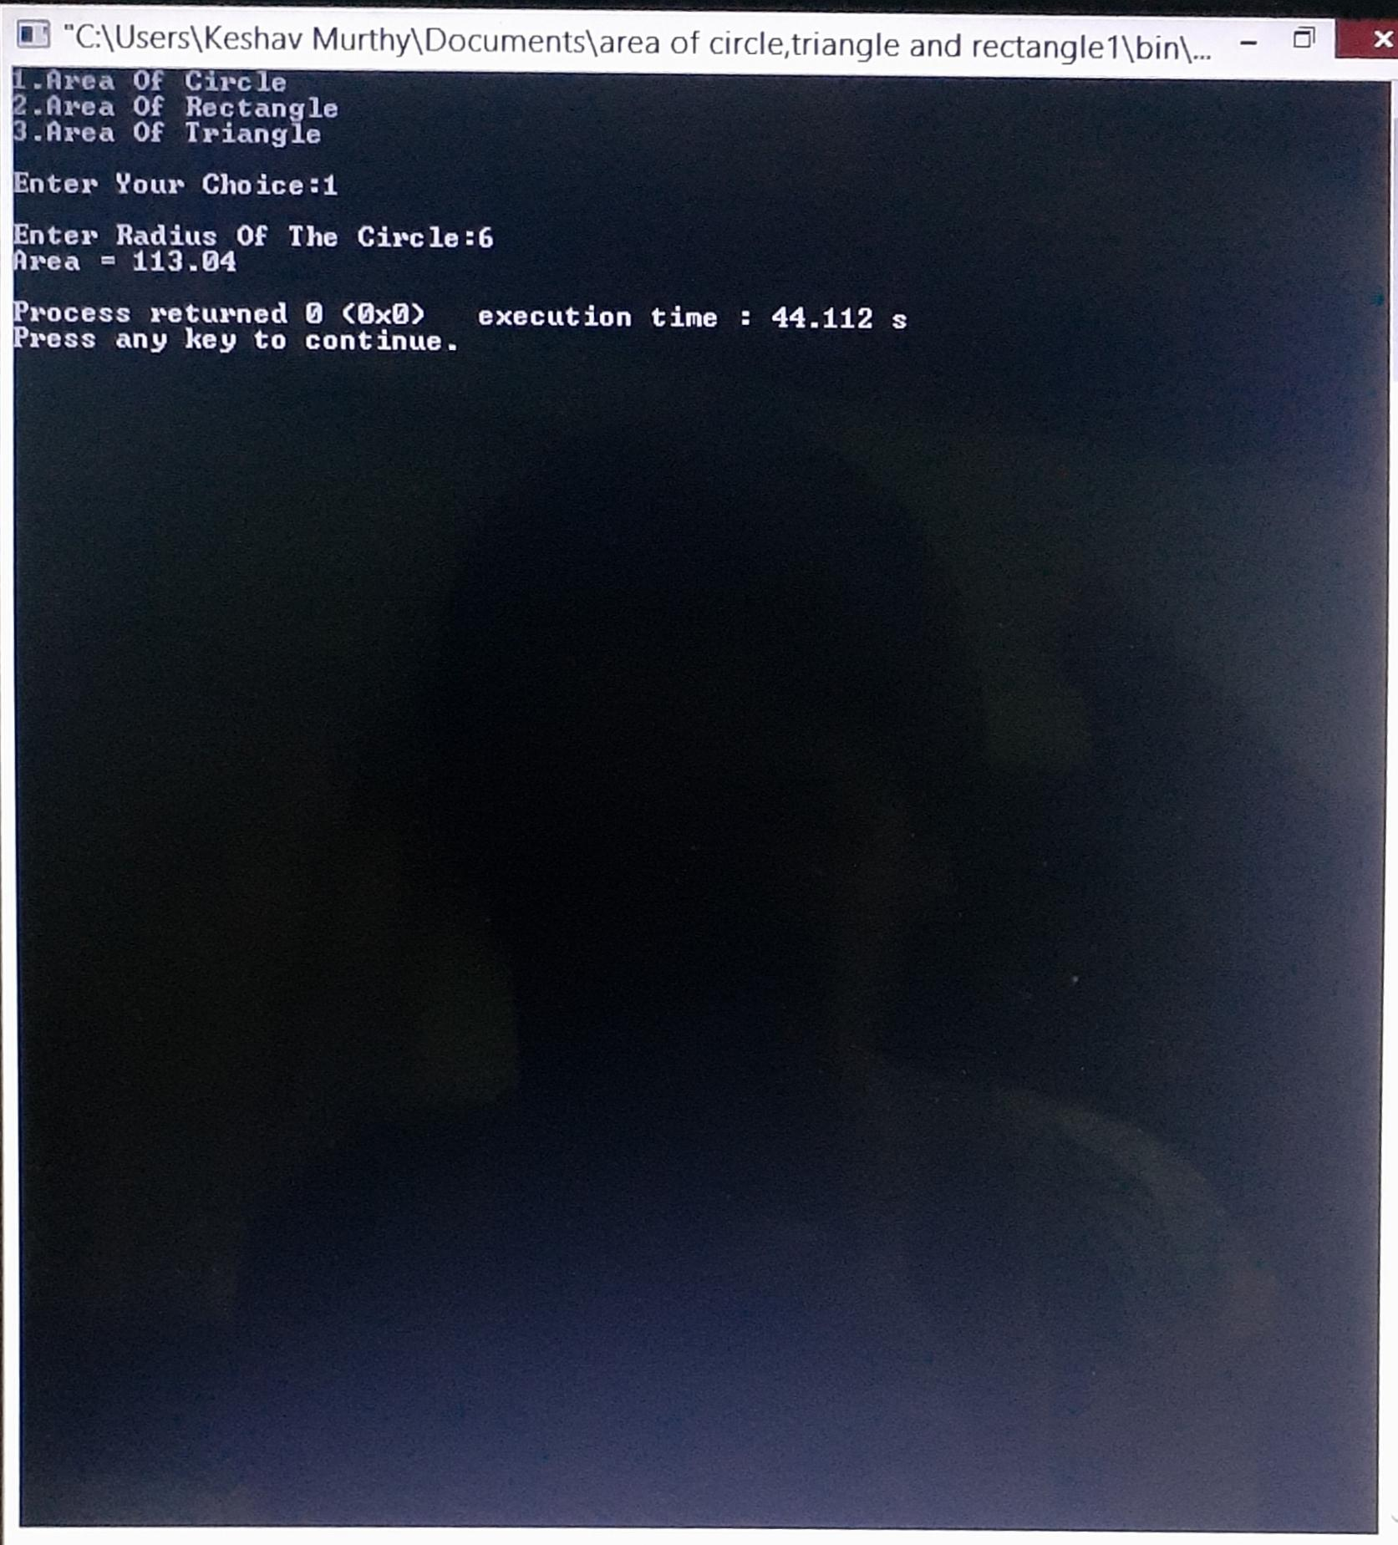Area of Circle :

Area of Rectangle :

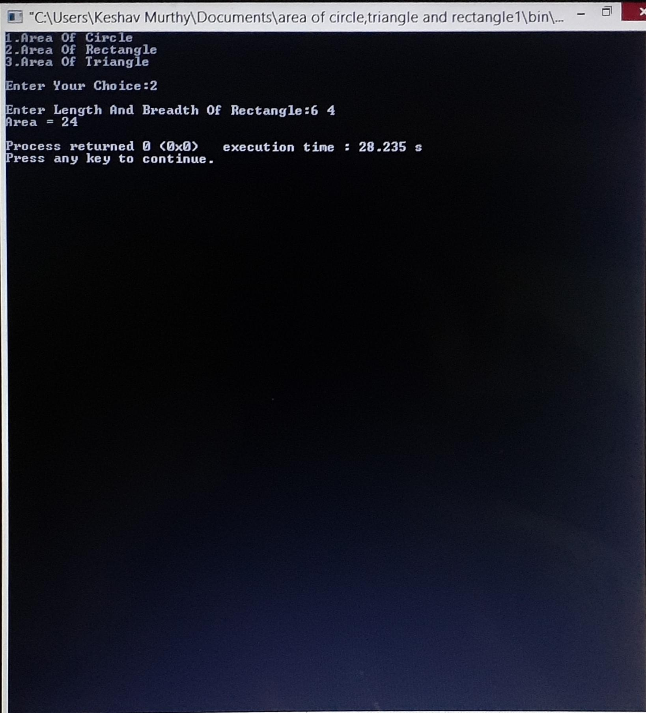

Area of Triangle :

